**BRD**

1. **Current Business Problem**:
   * 1. At the time of checkout, the cashier do not have an ability to remove / Delete the tax for a customer that has a non-profit business account. As a result of this we are losing the business of non-profit business account users.
2. **Proposed Solution**:
   * 1. The goal of the project is to introduced an ability for the cashier to be able to enter the tax id of the non-profit business users and the system shall remove the taxes associated with the purchase.
3. **System(s) Impacted**:
   * 1. POS system
4. **Assumptions/ Dependencies**
   * 1. NO
5. **Business Requirements**:
   * 1. Ability for the cashier to enter the non-profit tax id
     2. Ability for the manager to approve / Cancel the request to tax exempt a purchase.

**Use Cases:**

**Use Case Name:** Enter Tax-Exempt ID

**Primary Actor:** Cashier, Manager

**Use Case Story:** This use case enables the use case to enter Tax-Exempt ID and help non-profit business customers remove the tax associated with the purchase.

**Trigger:** Cashier clicking ‘Enter Tax-Exempt ID’ hyperlink

**Pre-Condition:** None

**Post-Condition:** System removes the tax associated with the purchase

**Primary Flow:**

**Title:** Cashier is able to remove the Tax associated with the purchase.

|  |  |
| --- | --- |
| **Actor Action** | **System Response** |
| 1. Cashier clicks ‘Enter Tax-Exempt ID’   (Refer Wireframe 1) | 1. System displays a pop-up for the Cashier to enter Tax-Exempt ID (refer Wireframe 2) |
| 1. Cashier enters the Tax-ID |  |
| 1. If the Cashier decides to click ‘Submit’ button, go to next step,   Else,  If the cashier decides to click ‘Cancel’ button, go to Exception Flow 1 (EF1) |  |
| 1. Cashier clicks ‘Submit’ button | 1. System validates the Tax-ID format.   If valid, go to next step,  Else,  If invalid, go to Alternate Flow 1 (AF1) |
|  | 1. System validates if the entered Tax-ID is a Tax-Exempt ID.   If a Tax-Exempt ID, go to next step,  Else,  If not a Tax-Exempt ID, go to Exception Flow 2 (EF2) |
|  | 1. System checks the value of tax-exempt amount.   If the amount is <=50, go to next step,  Else,  If the amount is > $50, go to Alternate Flow 2 (AF2) |
|  | 1. System closes  * the pop-up * updates the Tax to $0.00 * updates the grand total * Hides ‘Enter Tax-Exempt ID’ link   (Refer Wireframe 3) |

**Alternate Flow 1 (AF1):**

**Title:** Invalid Tax-ID Format

|  |  |
| --- | --- |
| **Actor Action** | **System Response** |
|  | 1. System displays the following error message: Invalid Tax-ID format   (Refer Wireframe 4) |
| 1. Go to step 3 of PF. |  |

**Alternate Flow 2 (AF2):**

**Title:** Tax amount >$50

|  |  |
| --- | --- |
| **Actor Action** | **System Response** |
|  | 1. System displays the pop-up for Manager Approval   (Refer Wireframe 5) |
| 1. Manager enters the username and pin |  |
| 1. If the Manager decides to click ‘Submit’ button, go to next step,   Else,  If the Manager decides to click ‘Cancel’ button, go to Exception Flow 1 (EF1) |  |
| 1. Manager clicks ‘Submit’ button | 1. System validates the User ID and Pin.   If valid, go to next step,  Else,  If invalid, go to Alternate Flow 3 (AF3) |
|  | 1. Go to step 9 of PF |

**Alternate Flow 3 (AF3):**

**Title:** Invalid Manager User ID/Pin

|  |  |
| --- | --- |
| **Actor Action** | **System Response** |
|  | 1. System displays the following error message: Invalid User ID/Pin   (Refer Wireframe 6) |
| 1. Go to step 2 of Alternate Flow 2 (AF2) |  |

**Exception Flow 1 (EF1):**

**Title:** Invalid Manager User ID/Pin

|  |  |
| --- | --- |
| **Actor Action** | **System Response** |
| 1. Cashier/Manager clicks ‘Cancel’ button | 1. System closes the pop-up and the tax value remains the same. |

**Exception Flow 2 (EF2):**

**Title:** Tax ID Entered is Not Tax Exempt

|  |  |
| --- | --- |
| **Actor Action** | **System Response** |
|  | 1. System does the following:  * Displays the following error message: Entered Tax ID is NOT tax-Exempt * Hides ‘Submit’ button   (Refer Wireframe 7) |
| 2. Cashier clicks ‘Cancel’ button | 3. System closes the pop-up and the tax value remains the same. |

**Appendix**

**Wireframe 1:**

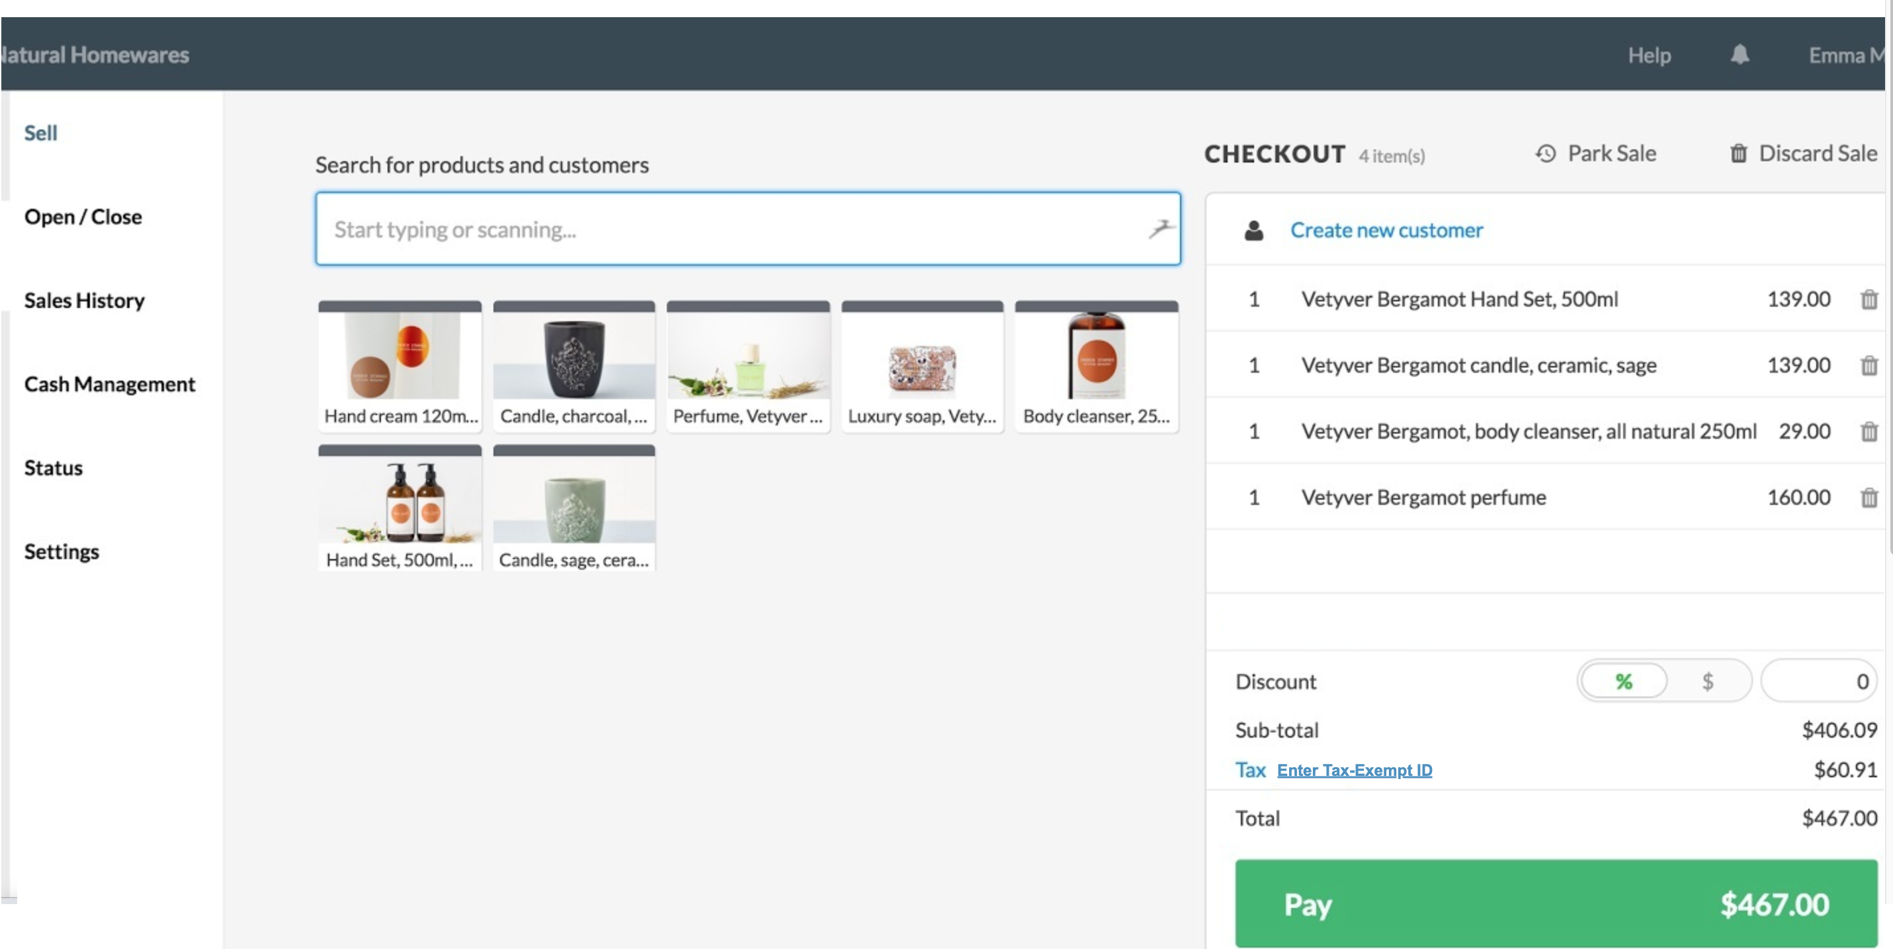

|  |  |  |  |  |  |
| --- | --- | --- | --- | --- | --- |
| **Field Name** | **Field Type** | **Required?** | **Min. Char** | **Max Char** | **Notes** |
| Enter Tax-Exempt ID | Hyperlink | No | N/A | N/A | On click, displays the pop-up for the cashier to enter Tax-Exempt ID |

**Wireframe 2:**

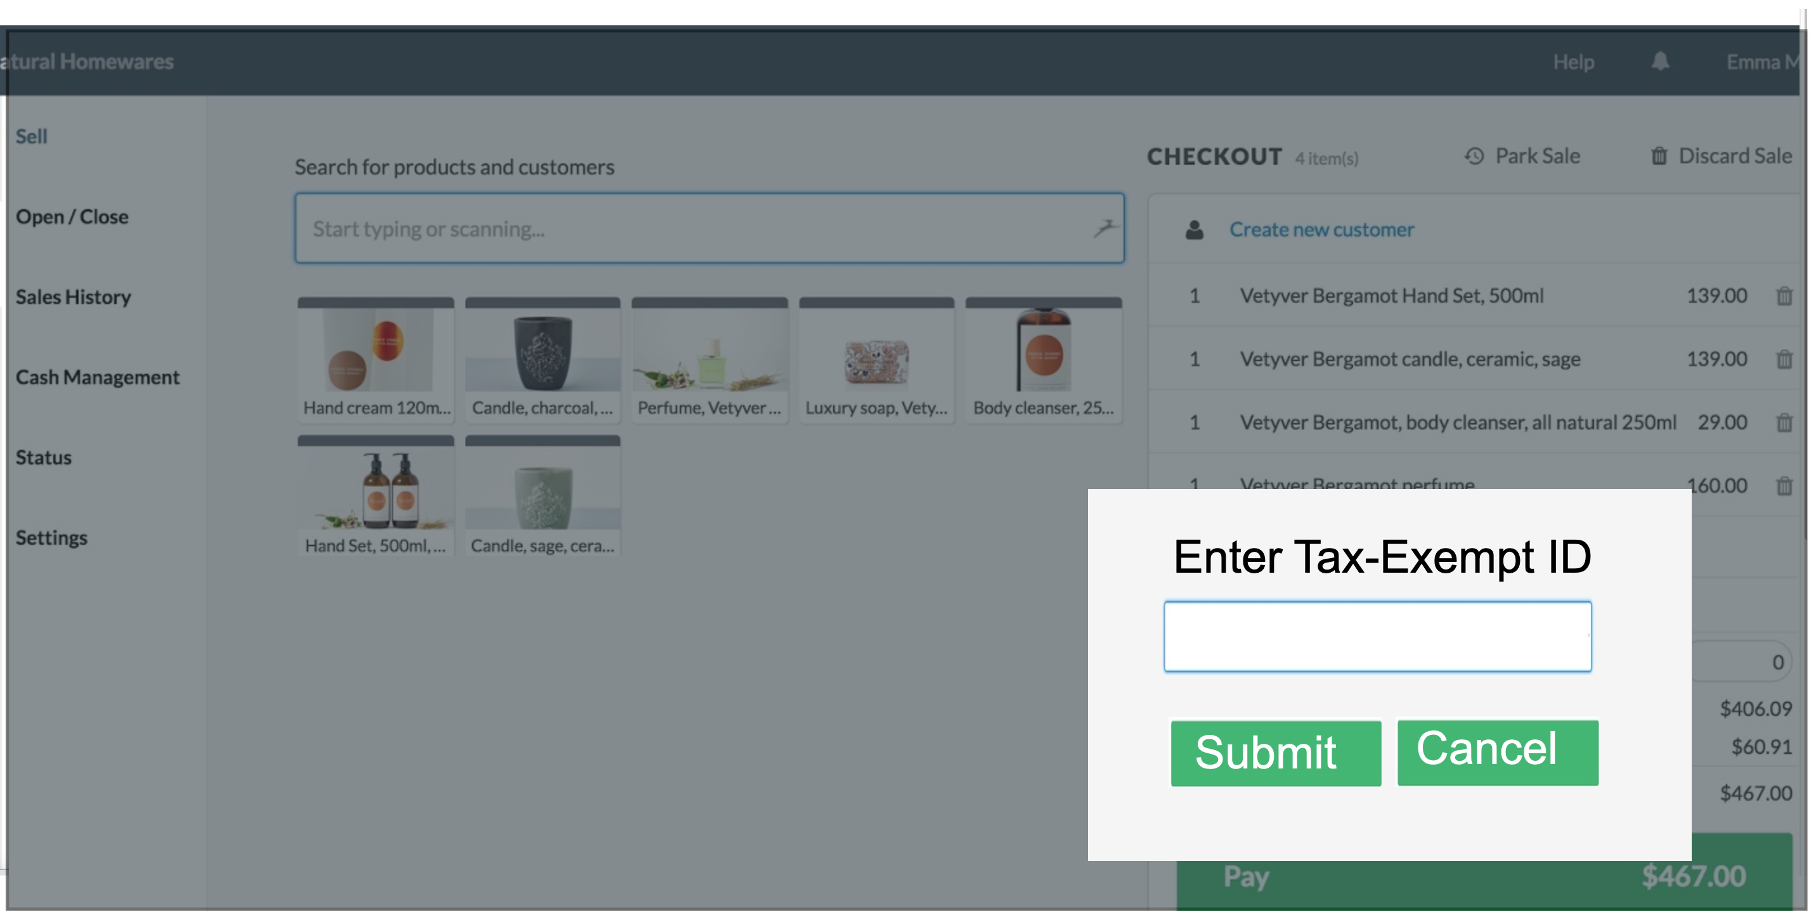

|  |  |  |  |  |  |  |
| --- | --- | --- | --- | --- | --- | --- |
| **Field Name** | **Field Type** | **Data Type** | **Required?** | **Min. Char** | **Max Char** | **Notes** |
| Enter Tax-Exempt ID | Text Box | Numeric | Yes | 9 | 9 |  |
| Submit | Button | N/A | N/A | N/A | N/A | On click, if validations pass:   * Displays manager approval pop up if Tax amount >50, closes the pop-up |
| Cancel | Button | N/A | N/A | N/A | N/A | Closes the pop-up |

**Wireframe 3:**

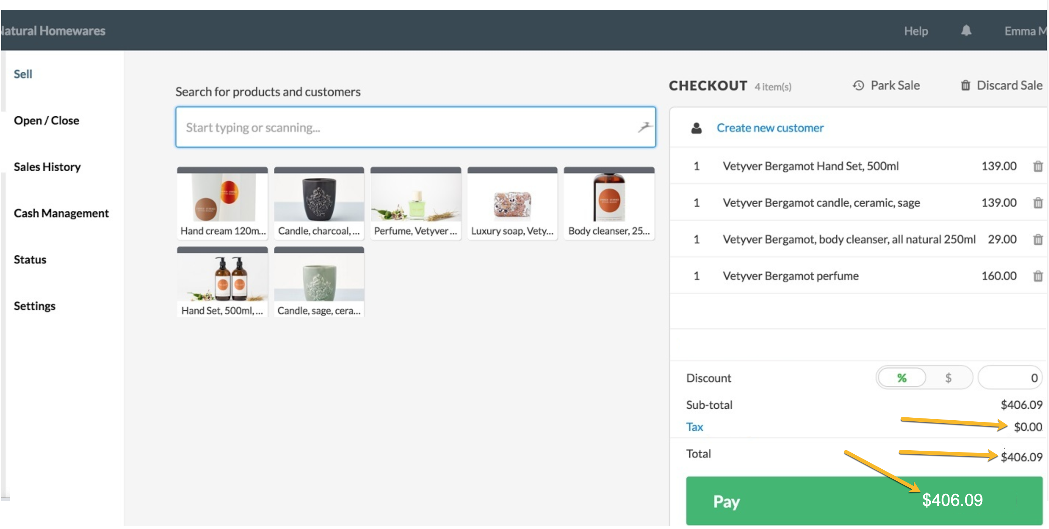

**Wireframe 4:**

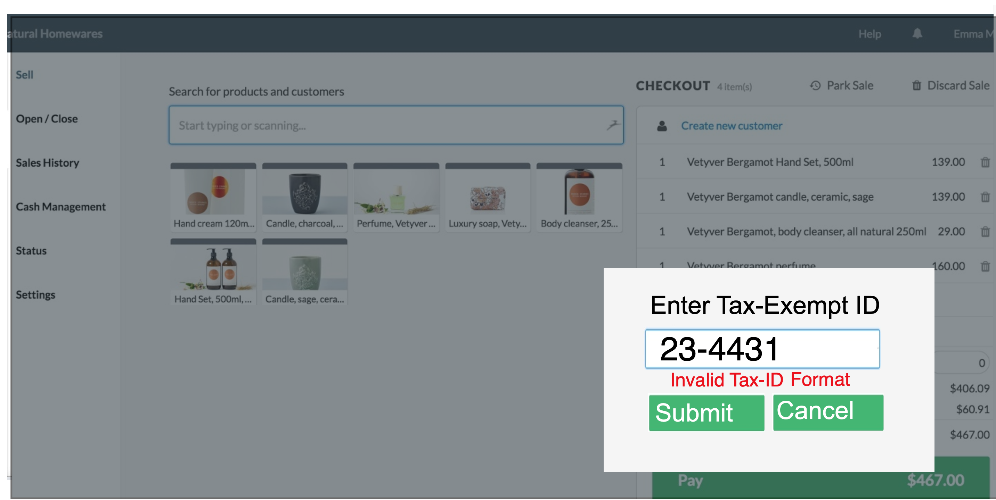

**Wireframe 5:**

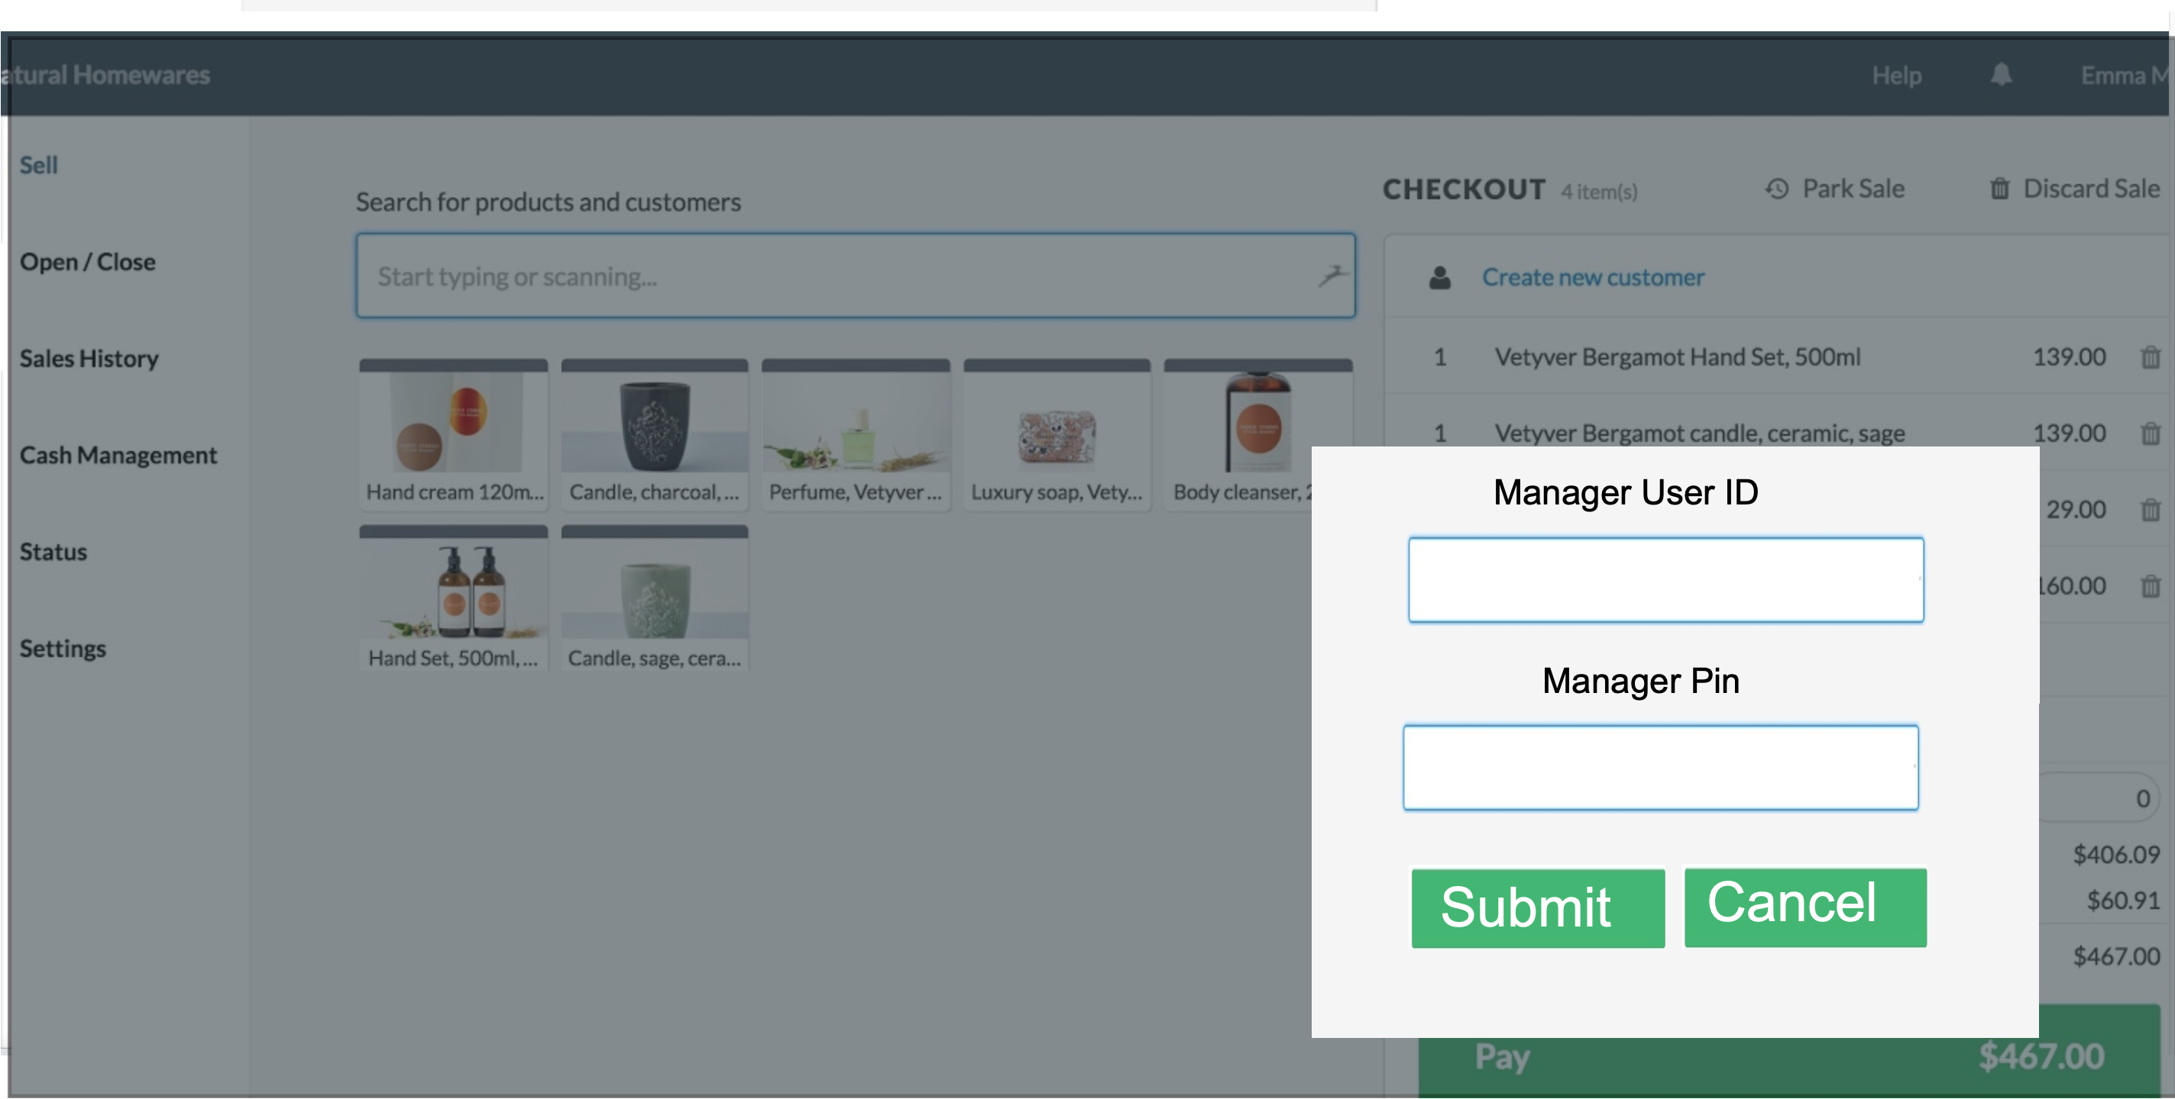

|  |  |  |  |  |  |  |
| --- | --- | --- | --- | --- | --- | --- |
| **Field Name** | **Field Type** | **Data Type** | **Required?** | **Min. Char** | **Max Char** | **Notes** |
| Manager User ID | Text Box | Alphanumeric | Yes | 5 | 5 |  |
| Manager Pin | Text Box | Numeric | Yes | 4 | 4 | Encrypt the entered data |
| Submit | Button | N/A | N/A | N/A | N/A | On click, if validations pass, close the pop else display error message |
| Cancel | Button | N/A | N/A | N/A | N/A | Closes the pop-up |

**Wireframe 6:**

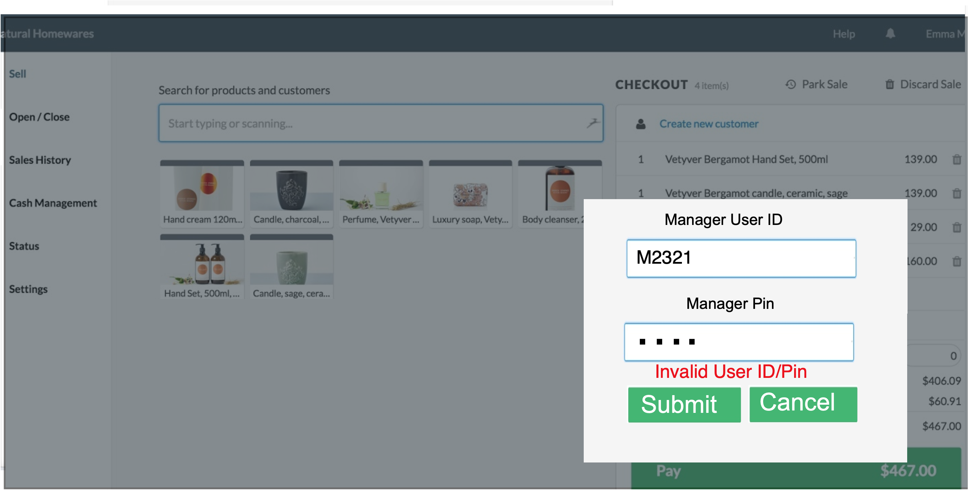

**Wireframe 7:**

